1) Retrieve the book title, category, and rental price of all available books.

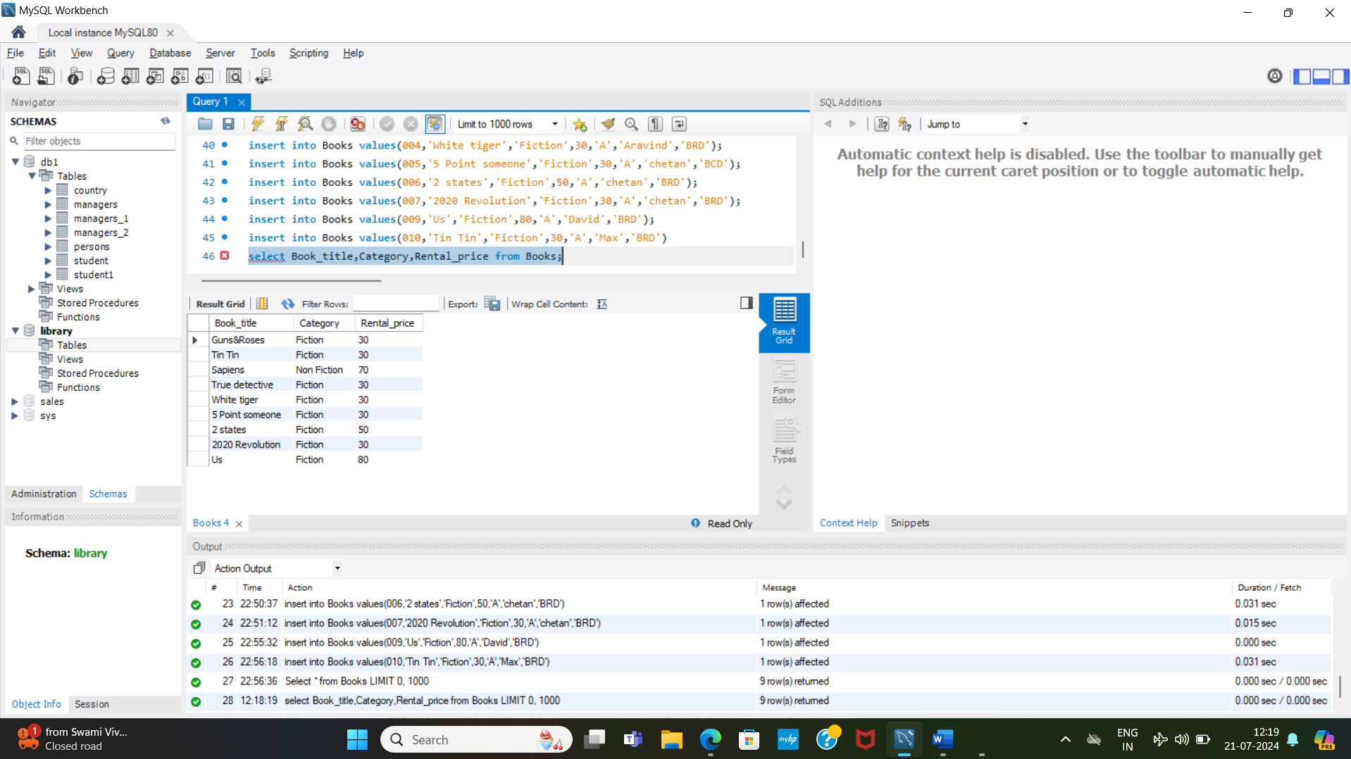

2) List the employee names and their respective salaries in descending order of salary.

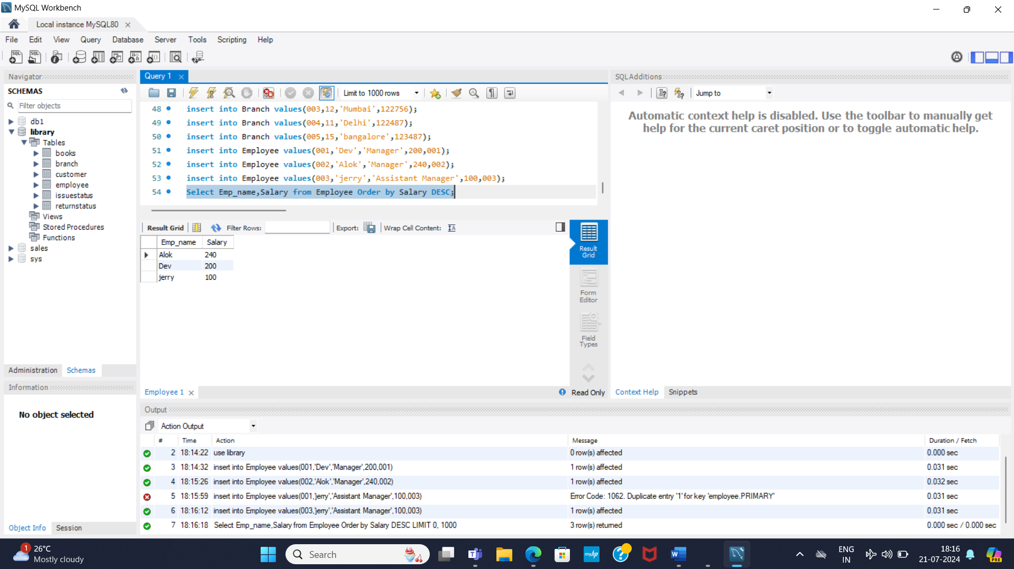

3)

4) Display the total count of books in each category.

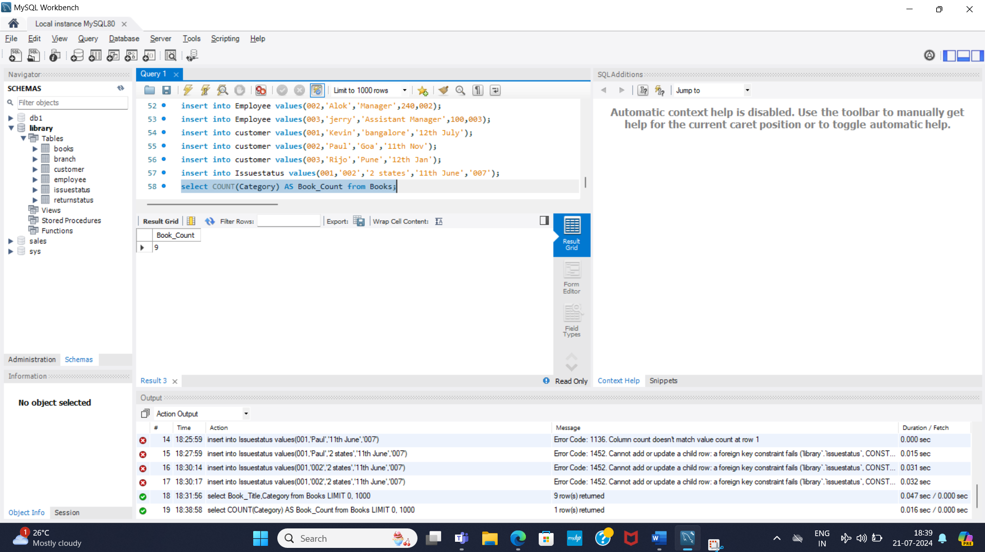

5) Retrieve the employee names and their positions for the employees whose salaries are above Rs.50,000.

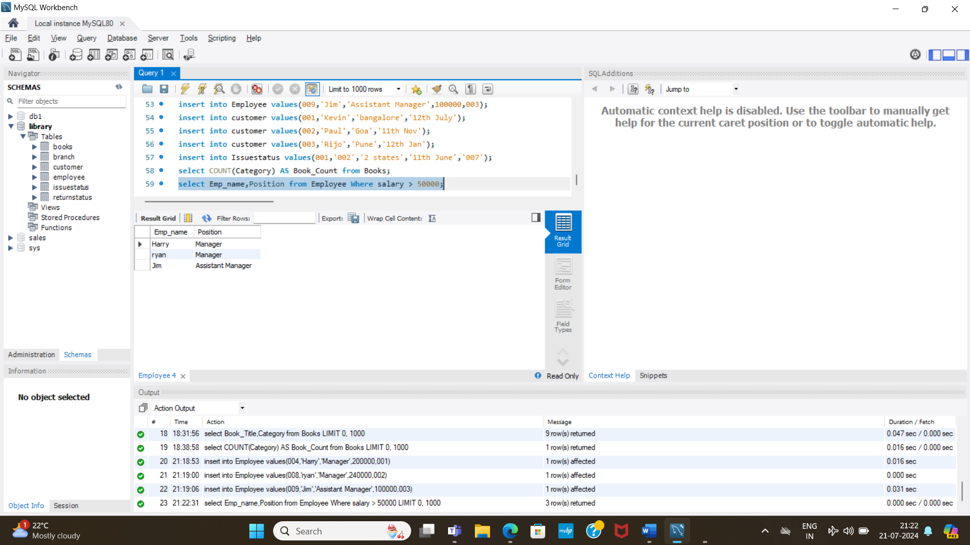

*///////////////////////89  
0.00000+

3.

+582366666666666.0222222222……2.111’’

1

7) Display the branch numbers and the total count of employees in each branch.

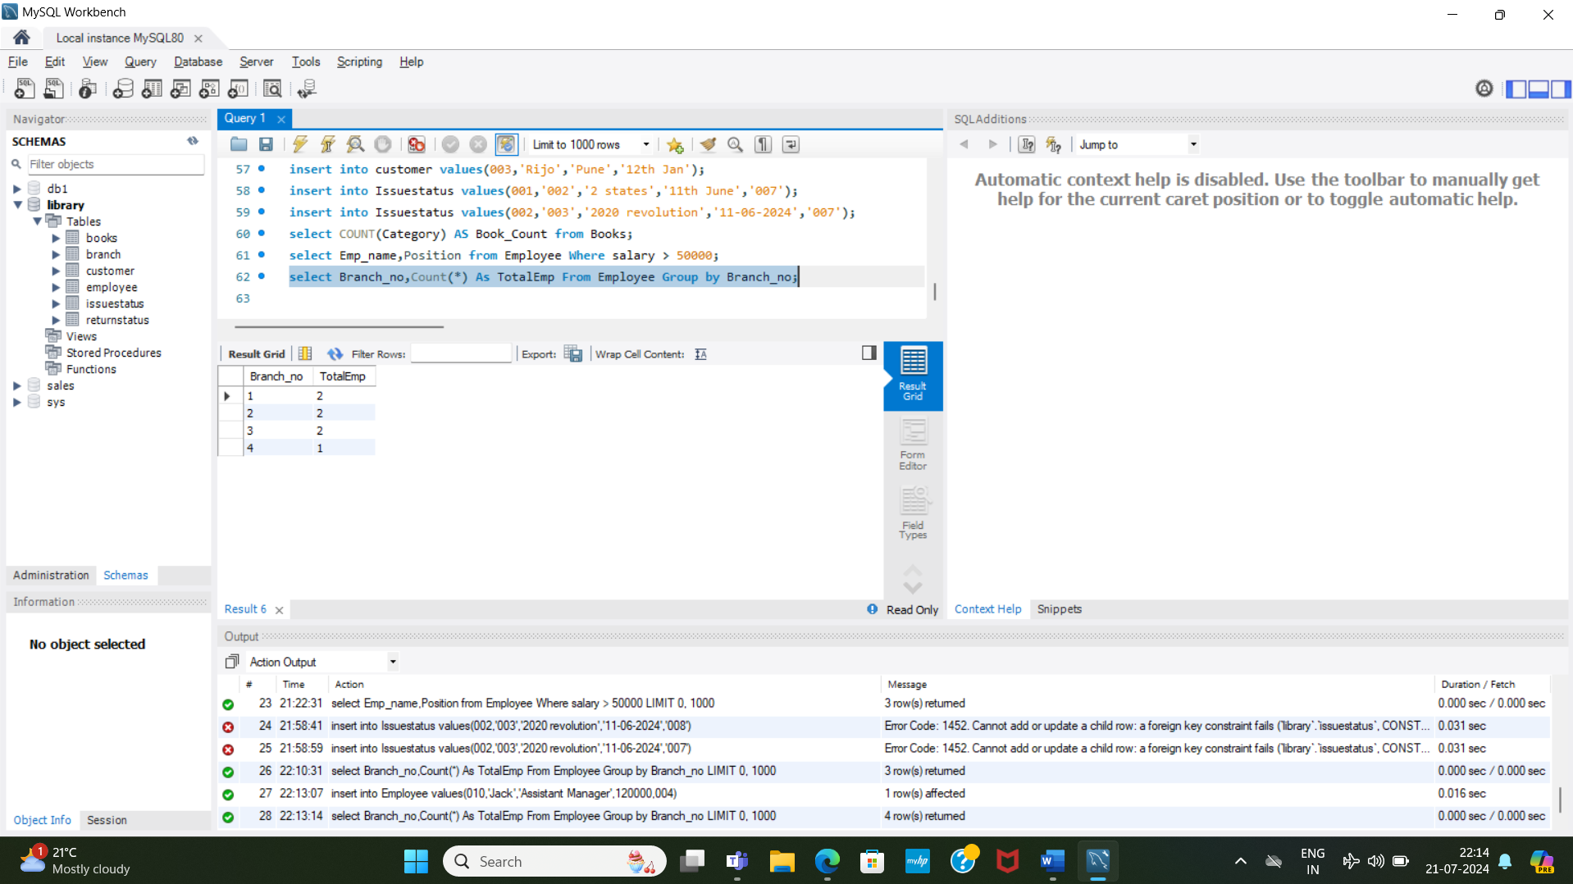

11) Retrieve the names of employees who manage branches and their respective branch addresses

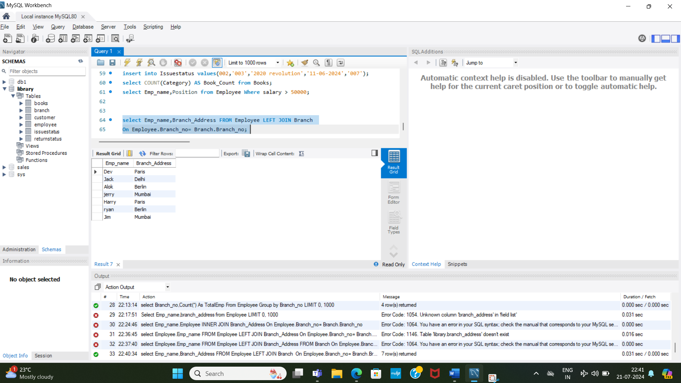

* Goal-driven professional with **3.5+ years** of experience in **Policy Operations, Technical Writing, Process Improvement, Cross functional Stake holders’ management** and other related activities

+54-55….\